**PalindromeWSApplication:**

/*

* To change this license header, choose License Headers in Project Properties.

* To change this template file, choose Tools | Templates

* and open the template in the editor.

*/

package org.me.palindrome;

import javax.jws.WebService;

import javax.jws.WebMethod;

import javax.jws.WebParam;

/**

*

* @author dadas

*/

@WebService(serviceName = "PalindromeWS")

public class PalindromeWS {

/**

* Web service operation

*/

@WebMethod(operationName = "checkPalindrome")

public boolean checkPalindrome(@WebParam(name = "text") String text) {

String cleanText = text.replaceAll("[^a-zA-Z0-9]", "").toLowerCase();

String reversed = new StringBuilder(cleanText).reverse().toString();

return cleanText.equals(reversed);

}

}

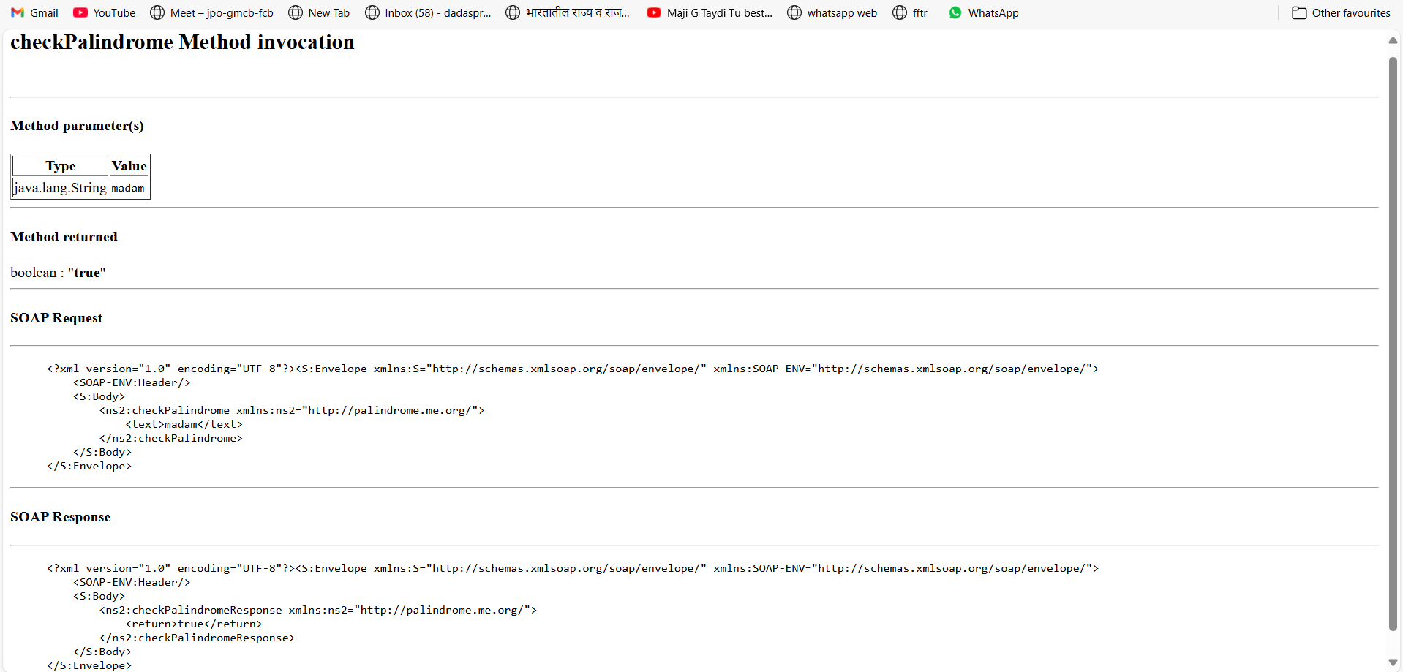

**PalindromeWS_Client_Application:**

/*

* To change this license header, choose License Headers in Project Properties.

* To change this template file, choose Tools | Templates

* and open the template in the editor.

*/

package palindromews_client_application;

public class PalindromeWS_Client_Application {

public static void main(String[] args) {

try {

String inputText = "madam";

boolean result = isPalindrome(inputText);

System.out.println("Is \"" + inputText + "\" a palindrome? " + result);

} catch (Exception ex) {

System.out.println("Exception: " + ex);

}

}

private static boolean isPalindrome(java.lang.String text) {

org.me.palindrome.PalindromeWS_Service service = new org.me.palindrome.PalindromeWS_Service();

org.me.palindrome.PalindromeWS port = service.getPalindromeWSPort();

return port.checkPalindrome(text);

}

}

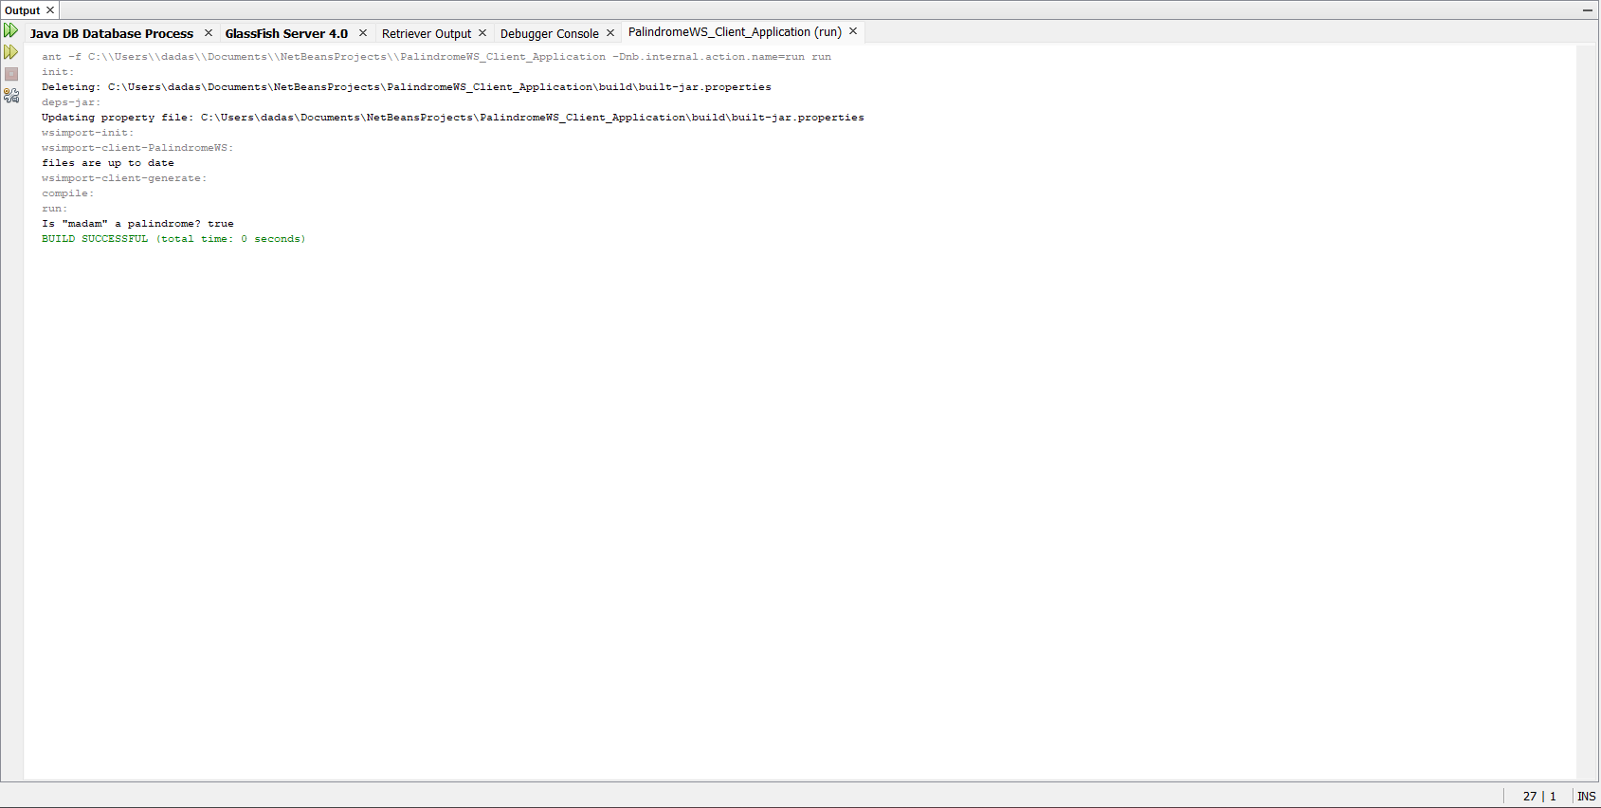

**PalindromeWSServletClient:**

/*

* To change this license header, choose License Headers in Project Properties.

* To change this template file, choose Tools | Templates

* and open the template in the editor.

*/

package org.me.palindrome.client;

import java.io.IOException;

import java.io.PrintWriter;

import javax.servlet.ServletException;

import javax.servlet.annotation.WebServlet;

import javax.servlet.http.HttpServlet;

import javax.servlet.http.HttpServletRequest;

import javax.servlet.http.HttpServletResponse;

import javax.xml.ws.WebServiceRef;

import org.me.palindrome.PalindromeWS_Service;

/**

*

* @author dadas

*/

@WebServlet(name = "ClientServlet", urlPatterns = {"/ClientServlet"})

public class ClientServlet extends HttpServlet {

@WebServiceRef(wsdlLocation = "WEB-INF/wsdl/localhost_8080/PalindromeWSApplication/PalindromeWS.wsdl")

private PalindromeWS_Service service;

/**

* Processes requests for both HTTP <code>GET</code> and <code>POST</code>

* methods.

*

* @param request servlet request

* @param response servlet response

* @throws ServletException if a servlet-specific error occurs

* @throws IOException if an I/O error occurs

*/

protected void processRequest(HttpServletRequest request, HttpServletResponse response)

throws ServletException, IOException {

response.setContentType("text/html;charset=UTF-8");

try (PrintWriter out = response.getWriter()) {

/* TODO output your page here. You may use following sample code. */

out.println("<!DOCTYPE html>");

out.println("<html>");

out.println("<head>");

out.println("<title>Servlet ClientServlet</title>");

out.println("</head>");

out.println("<body>");

out.println("<h1>Servlet ClientServlet at " + request.getContextPath() + "</h1>");

try {

String inputText = "madam";

boolean result = checkPalindrome(inputText);

out.println("Is \"" + inputText + "\" a palindrome? " + result);

} catch (Exception ex) {

out.println("Exception: " + ex);

}

out.println("</body>");

out.println("</html>");

}

}

// <editor-fold defaultstate="collapsed" desc="HttpServlet methods. Click on the + sign on the left to edit the code.">

/**

* Handles the HTTP <code>GET</code> method.

*

* @param request servlet request

* @param response servlet response

* @throws ServletException if a servlet-specific error occurs

* @throws IOException if an I/O error occurs

*/

@Override

protected void doGet(HttpServletRequest request, HttpServletResponse response)

throws ServletException, IOException {

processRequest(request, response);

}

/**

* Handles the HTTP <code>POST</code> method.

*

* @param request servlet request

* @param response servlet response

* @throws ServletException if a servlet-specific error occurs

* @throws IOException if an I/O error occurs

*/

@Override

protected void doPost(HttpServletRequest request, HttpServletResponse response)

throws ServletException, IOException {

processRequest(request, response);

}

/**

* Returns a short description of the servlet.

*

* @return a String containing servlet description

*/

@Override

public String getServletInfo() {

return "Short description";

}// </editor-fold>

private static boolean checkPalindrome(java.lang.String text) {

org.me.palindrome.PalindromeWS_Service service = new org.me.palindrome.PalindromeWS_Service();

org.me.palindrome.PalindromeWS port = service.getPalindromeWSPort();

return port.checkPalindrome(text);

}

}

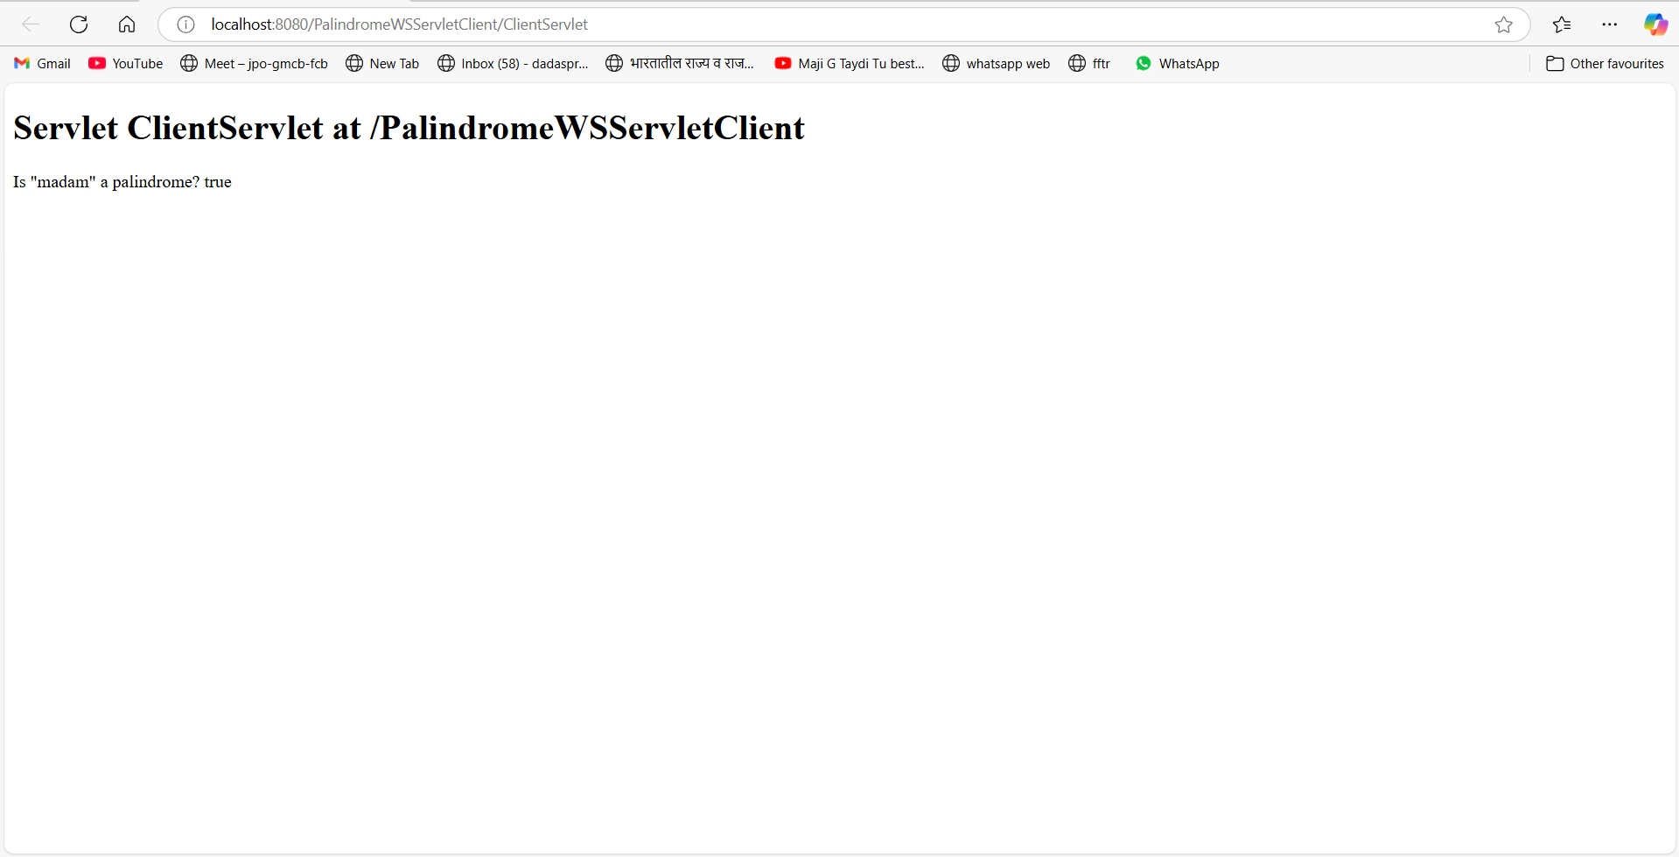

**PalindromeWSJSPClient:**

<%@page contentType="text/html" pageEncoding="UTF-8"%>

<!DOCTYPE html>

<html>

<head>

<meta http-equiv="Content-Type" content="text/html; charset=UTF-8">

<title>JSP Page</title>

</head>

<body>

<h1>Hello World!</h1>

<%-- start web service invocation --%><hr/>

<%

try {

org.me.palindrome.PalindromeWS_Service service = new org.me.palindrome.PalindromeWS_Service();

org.me.palindrome.PalindromeWS port = service.getPalindromeWSPort();

// TODO initialize WS operation arguments here

java.lang.String text = "madam";

// TODO process result here

boolean result = port.checkPalindrome(text);

out.println("Input Text: " + text + "<br>");

out.println("Is Palindrome? " + result);

} catch (Exception ex) {

// TODO handle custom exceptions here

out.println("Exception: " + ex.getMessage());

}

%>

<%-- end web service invocation --%><hr/>

</body>

</html>

